Rick Brophy

ECE1188 – Cyberphys

Dr. Dickerson

Due: 4/15/24

Lab 6:

1. Weather Terminal Screenshots

1. RSSI Screenshots

Friis equations denotes that power received is inversely related to the square of distance. Hence, there is a quadratic relationship between distance and RSSI.

1. MQTT Screenshots (2 different devices)

1. Controlling the motor using MQTT: <https://youtube.com/shorts/l2E02x1tLHQ?si=kvuTCDSjxhw9m46F>
2. Logged into node red (I split up to view better)

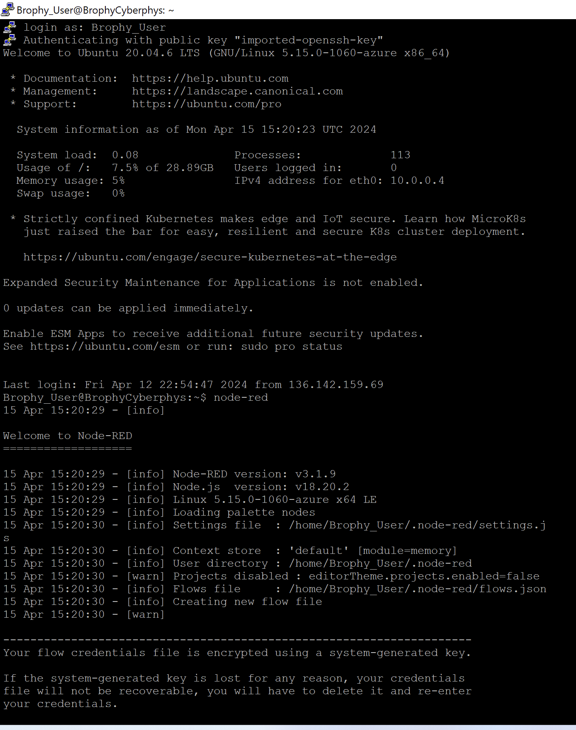

1. Node Red running on server
   1. Web links (not sure how you are supposed to access this so I will have ss)
      1. <http://172.187.229.243:1880/>
      2. <http://172.187.229.243:1880/ui>

This is my flow for node red, I used the “split” and “switch” node to parse through 1 MQTT command (1 publish topic for the robot). Unsure if this was the correct way to do this because the web app became very slow when updating all 5 values: 2 RPM and 3 distances values. The first split node uses “, “ to separate different data (Left RPM, Right RPM, 3 distances). The switch case places each line appropriately then the next split & switch nodes together can extract the numerical value. This value is then placed into either the gauges (RPM) or text field (distances).

Unfortunately, I was unable to get everything working together as youll see in the videos below. I can easily start and stop the motor with the switch button, but it does not work when also updating the RPM values. I could not get the distance sensor to work at all, and sometimes the sensor would somehow disable the robot from successfully connect to the MQTT Broker. Very odd. But, when transmitting the data in the correct form from my phone, I am able to update all 5 values (this is the last video to prove my flow would work with correct code). I have 3 node red videos uploaded.

Video 1 (Motor start/stop via website):

<https://youtu.be/Vam2VUUD-ZU?si=sxpQiRr_5capgxMk>

Video 2 (Motor RPM uploaded via robot): <https://youtu.be/Qe1rEoBmJwo?si=E1FAJT8roSmqbjSG>

Video 3 (All values uploaded via MQTTool):

<https://youtube.com/shorts/dUO7wqhY0EI?si=eSjUpYAoo4v8pEJy>